**Creating a Skype Meeting**

Adhoc

1. Open the skype Client from the Start Menu
2. In the Find Someone Box search for a user you want to meet with.

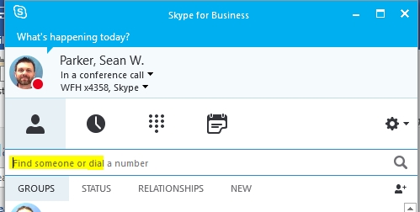

1. Double Click on the user to pull up a IM Conversation Window
2. Click the Invite More people icon on the top left

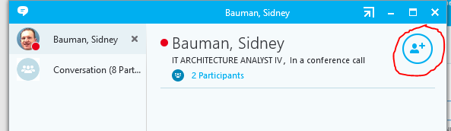

1. Search for the additional person you want to join the conversation and double click the user you want to add to the conversation. Repeat step for and 5 to add additional users.

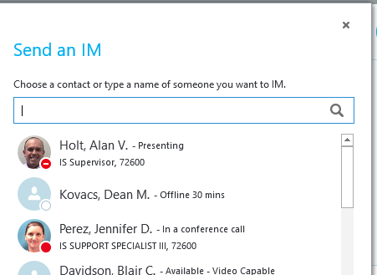

Adding to an Outlook Meeting

1. Open Skype or ensure it is running
2. Open Outlook and go to your calendar
3. Click on the “New Skype Meeting” icon

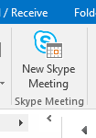

1. This will open a New window for a calendar invite. Enter the meeting invite details as normal, add attendees and set dates/times. You can also adjust the Skype Meeting Options such as setting “callers announcing” as they join.

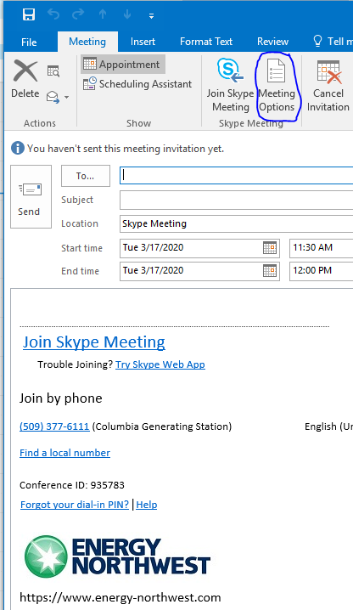

**Joining a Skype Meeting**

**From an EN Laptop Offsite**

1. EN laptops have Skype enabled by default. If you are going to use Horizon View to remote into EN and anticipate participating in a Skype session through the Horizon View client, then close the Skype connection on the EN Laptop. This can be done by:
2. In the bottom right corner of the screen click on the up arrow



1. Left Click on the Skype icon

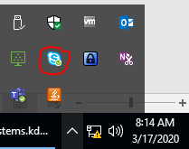

1. Select the menu option Exit

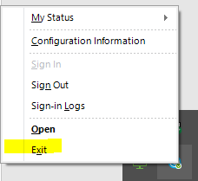

1. Now that you exited Skype on your local EN Laptop, you can open Skype in your Horizon View Remote session without conflict.
2. You can participate in a Skype meeting from an EN laptop offsite *without* remoting into EN first by just accessing the meeting invitation and clicking on the Join Skype meeting link. This will launch the meeting in the full Skype client.



Note: The calendar function does not work in this configuration, and several errors may momentarily appear as the session starts up. No action is required by the user to resolve the errors.

**From a Non-EN Computer**

You can participate in a Skype meeting from a non-EN computer with a small web application installation.

1. You will need access to the meeting invite link by either forwarding the invite to your personal email or accessing Outlook on the Web (requires RSA) you will want to use the “Try Skype Web App” link.



1. Once The application is installed choose the “Sign in if you are from the organizer’s company”

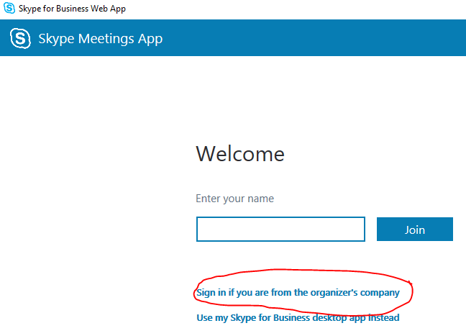

**Hosting a Skype Meeting**

**From an EN Computer**

1. Make sure Skype is running (you may have to open it for the first time from the start menue if logging into a new computer).
2. Open Outlook and open the meeting, choose “Join Skype Meeting”.
3. Choose your Audio options (Use Skype for Business (full audio and video experience) is the best option if you have a USB headset). 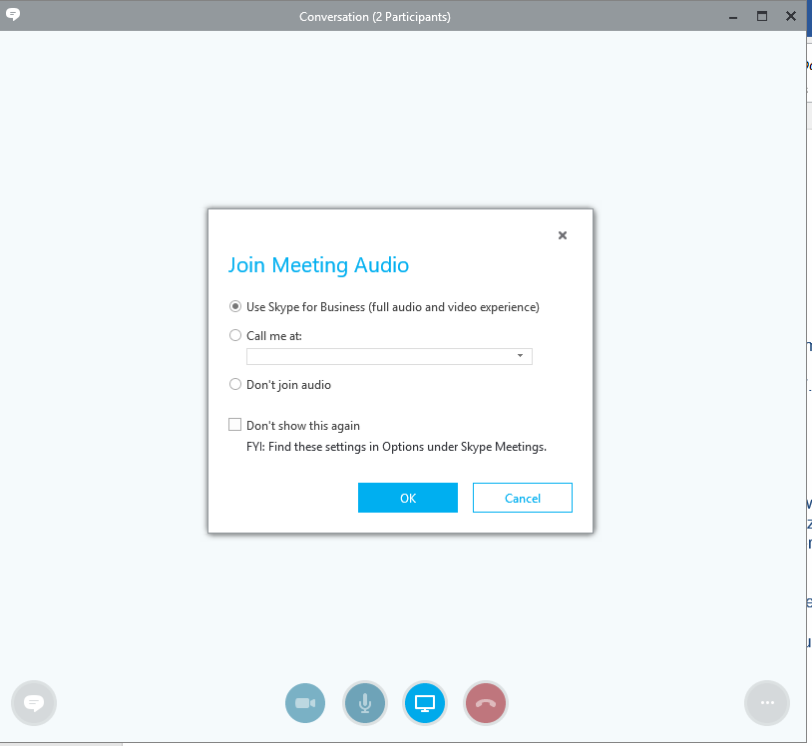
4. Once you are connected you can share your screen or conent, Start your video, or chat with the participants.

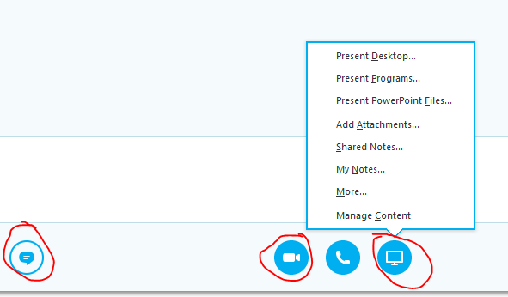

**From a Telephone**

If no one is going to join the meeting via the computer then someone will have to join by phone and choose the option that they are the “Meeting Organizer”. This is necessary to start the meeting and join all the parties together in the call.

1. Call the Skype Conference system and enter the Meeting code “Conference ID”

* Internal: Dial 6111 and enter the meeting code.
* External: Dial 377-6111 and enter the meeting code (AKA Conference ID).
* If you’re the leader Press *
* Enter your PIN (Default is your employee ID) (you can reset your pin here <https://dialin.energy-northwest.com/>)
  + If you did not Organize the meeting you can still start the meeting as a designated leader (all employees are designated leaders by default) then press # again when prompted
  + Enter you extension number and press #
  + Then enter your PIN when prompted

**Other Audio Options**

The Simplest way to join a Skype meeting Audio without dealing with built in microphones or headsets it to use the “[call me at](http://changegear/cgweb/MainUI/Print/PrintFrame.aspx?boundtable=IKBArticle&column=ID&columnValue=180)” feature.

This method works well for conference room meetings, **it does not work if you want to share your Video camera.**

If you are in a conference room and want to use a Video Camera then on the Conference room computer “Use Skype for Business (full audio and video experience)” and then MUTE the conference Room Computer speakers; then use the conference room phone to dial into the meeting and join as a guest.

* Internal: Dial 6111 and enter the meeting code.
* External: Dial 377-6111 and enter the meeting code (AKA Conference ID).

If you are unsure of the Meeting Code, you can find it on the calendar invite, or when you are in the meeting click the 3 dots on the bottom right and click Meeting Entry Info and look for the “Conference ID:”.

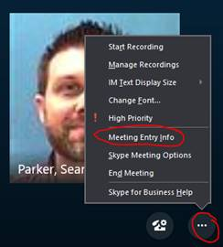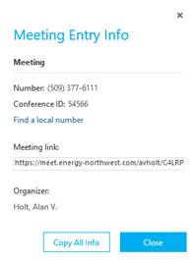

**Use your telephone for audi on during a meeting** 

You can join meeting audio using the call me at option when joining a meeting. This is an alternative to using a Skype headset. To use this feature:

1. When joining a meeting, select the Call me at option, then click New Number…  
   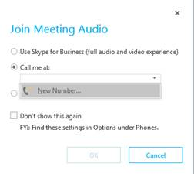
2. Enter a four digit extension for an internal extension, or 9 then an external phone number **just like you would dial on your Cisco phone**. Then click OK.  
   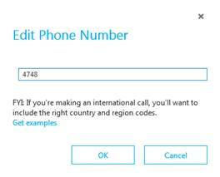
3. Skype should call your phone. Answer to join the audio.

**Starting Video During a conference Call or peer to peer conversation**

Make sure your camera is uncovered and click the Camera Icon, and then Click Start My Video.

